Research Strategy Default Backtest Report
Strategy / EA: LRB V1.0
Expert: LRB V1.0.ex5 | Symbol: EURUSD dukascopy | Timeframe: M15
Backtest Period: 2013.01.01 -> 2026.07.03 | Initial Deposit: $5,000.00
Generated: 2026-09-24 09:57:58 UTC
This report documents the DEFAULT (un-optimised baseline) backtest for this researched strategy. It establishes baseline performance and trade mechanics directly from the EA's core MQL5 implementation prior to running genetic parameter optimization and robustness stress-tests.

Key Performance Metrics
Metric | Value
Net Profit ($) | -2,786.6700
Net Profit (%) | -55.7334
Profit Factor | 0.6100
Sharpe Ratio | -5.0000
Max Balance Drawdown (%) | 56.4700
Recovery Factor | -0.9600
Win Rate (%) | 40.4900
Total Trades | 447
Largest Profit Trade ($) | 50.0000
Largest Loss Trade ($) | -50.0000

Equity & Performance Charts
Chart Equity Growth
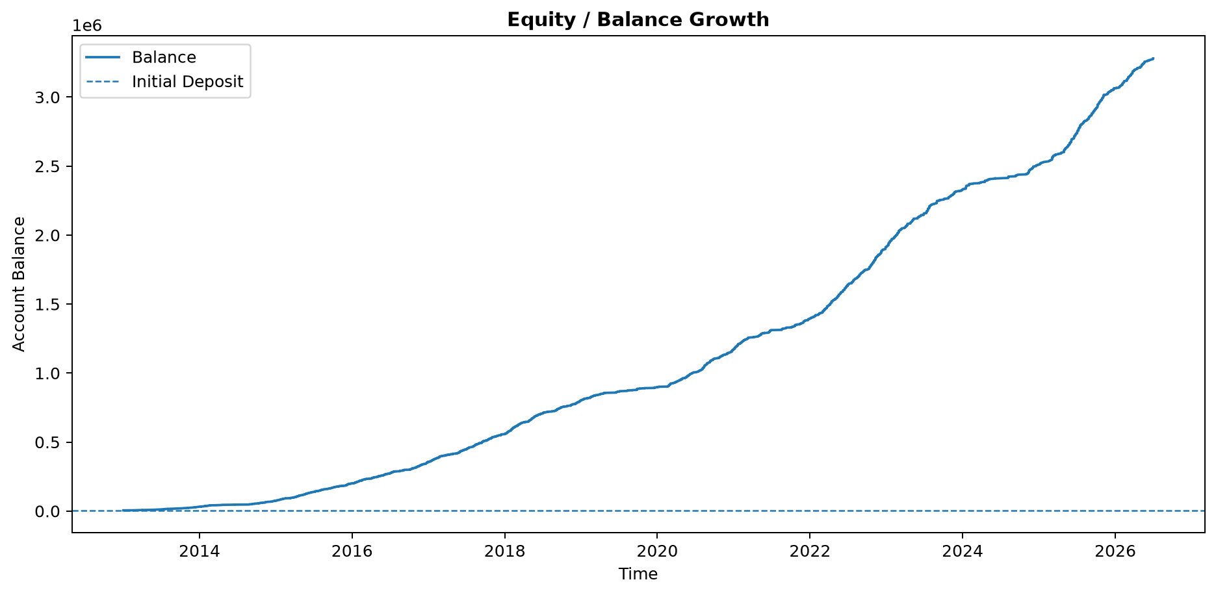

Chart Percent Gain
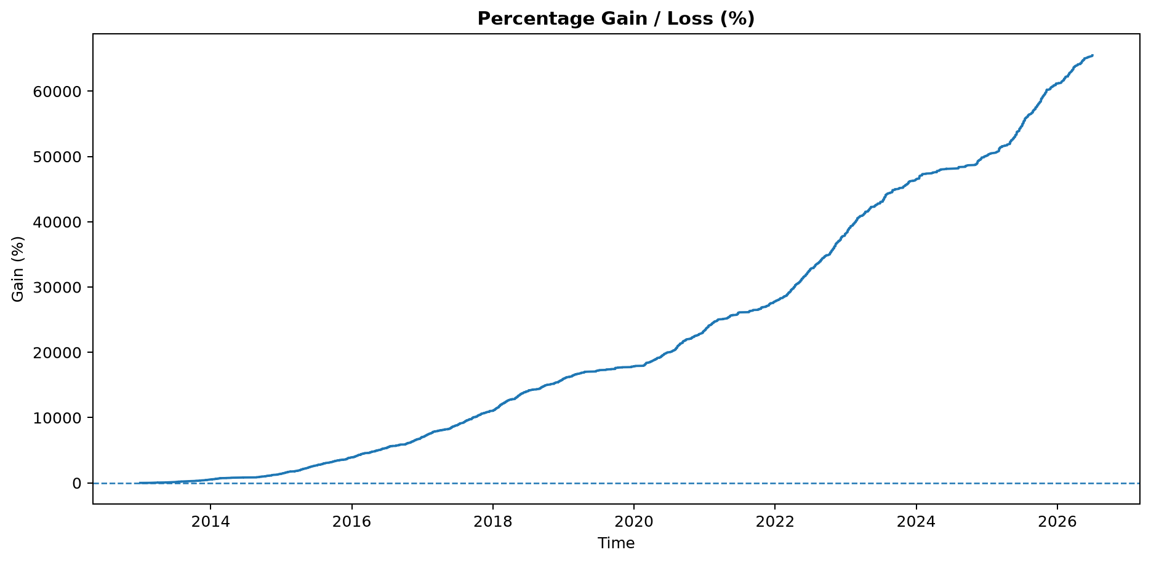

Chart Profit Dollars
